A REPORT
ON
(SRMS STUDENT PORTAL)
By

Name of the Student: Registration no:
Vemula Aasritha AP24110010443

Prepared in the partial fulfillment of the
Project Based Learning of Course CSE 201: Coding Skills-I



SRM UNIVERSITY, AP

DECEMBER 2025

ACKNOWLEDGEMENT

I would like to extend my heartfelt thanks to Prof. C. V. Tomy, the Dean of the School of Engineering and Sciences, for his invaluable support and guidance throughout this journey.

I am really grateful to my Faculty Mentor, Mr. Prakash, for his valuable advice, constant guidance, and encouragement, which shaped this project from its initiation to completion. His experience and valuable suggestions helped a lot in refining and perfecting the work.

I would also like to extend special appreciation to my friends for their technical assistance and collaborative discussions that played an essential role during the development stages of this project.

Finally, I am indeed grateful to SRM University AP for the opportunity to turn theoretical knowledge into meaningful, practical experience.

CERTIFICATE

This is to certify that the project entitled SRMS Student Portal has been successfully completed by Vemula Aasritha (Roll No: AP24110010443) as a required academic component of the course CSE 201: Coding Skills-I during Semester 3 of Academic Year 2025-26 in the Department of Computer Science and Engineering at SRM University, AP. This work was executed under the guidance of the undersigned and is deemed to have successfully met all course requirements as of 06/11/2025.

(Signature of the Course Instructor)
Prakash,
Coding Skills-I,
Department of Computer Science and Engineering
SRM University, AP

ABSTRACT:
This project implements a simple, menu-driven Student Management System using C++. The system allows users to securely log in and perform essential operations on student records stored in memory using vectors. Through an interactive console interface, the program supports adding new students, viewing all records, searching for a specific student, updating existing details, and deleting records. Each student’s information—roll number, name, and marks—is managed using a structured data type for better organization. The login mechanism ensures restricted access, allowing only authorized users to perform operations. The project demonstrates the practical application of C++ concepts such as structures, functions, loops, conditional statements, vectors, and basic authentication. Overall, this system provides an efficient and user-friendly approach to managing student information in a small academic environment.
INTRODUCTION:
The Student Management System developed in C++ is a simple console-based application designed to make handling student records faster, easier, and more organized. Manual record-keeping often leads to data loss, errors, and slow retrieval, whereas this system automates the entire process through a menu-driven interface. Using fundamental C++ concepts such as structures, vectors, functions, and loops, the program allows users to add new students, view all records, search for specific students, update details, and delete entries when necessary. Each record stores essential information such as roll number, name, and marks, all maintained dynamically using vectors for efficient access. The system also includes a basic login feature to ensure that only authorized users can perform operations. Overall, this project demonstrates how foundational C++ techniques can be used to build a functional and efficient tool for managing student information.

OBJECTIVES:
This project digitizes the storage of student information to ease management, reduces manual workload and errors, ensures access is secure, and allows for quick ways to search, edit, and delete records. The main problem being addressed involves the inefficiency of manual systems whereby locating or updating any information takes a lot of time and leads to frequent errors. In the automated system, these problems are eliminated by allowing files that store and process information in a structured manner.

EXISTING VS PROPOSED SYSTEM:
In the existing manual system, student records are kept in handwritten registers or simple spreadsheets, making data handling slow, inaccurate, and hard to update. These methods are insecure and often lead to misplaced or duplicated records. The proposed C++ Student Management System solves these issues by offering a digital and structured way to store and manage student data. With secure login, menu-driven options, and efficient use of structures and vectors, it ensures quicker processing, easier updates, and more reliable access. Overall, the system improves accuracy, reduces errors, and provides a convenient way to add, view, search, update, and delete student records.
FEASIBILITY AND REQUIREMENTS:
The Student Management System is highly feasible because it requires only basic C++ concepts and can run on any standard compiler without special hardware or paid software. Its menu-driven design makes it easy to use, even for beginners, ensuring smooth operation. Since it uses free tools and simple programming structures, the system is cost-effective, easy to implement, and practical for small institutions or individual users.

SYSTEM OVERVIEW AND DESIGN:
The Student Management System is a menu-driven C++ program designed to manage student details in an organized way. After a simple login, users can add, view, search, update, or delete student records, all handled through separate functions. Student information is stored using a structure and maintained in a vector for easy access. The system follows a clean, modular design that makes it easy to use, understand, and modify.

MODULES:
The system consists of the following major modules:
1. Login Module
- Purpose: Authenticate the user before allowing access to the system.
- Function: login()
- Description: Prompts for username and password, and grants access only if credentials match predefined values.
2. Add Student Module
- Purpose: Add new student records to the system.
- Function: addStudent()
- Description: Takes input for roll number, name, and marks, and stores it in the records vector.
3. View Students Module
- Purpose: Display all student records.
- Function: viewStudents()
- Description: Iterates through the records vector and prints details of each student.
4. Search Student Module
- Purpose: Find a student record by roll number.
- Function: searchStudent()
- Description: Searches the records vector and displays the record if found, else shows “Student Not Found.”
5. Update Student Module
- Purpose: Modify existing student records.
- Function: updateStudent()
- Description: Searches by roll number and updates name and marks if the record exists.

6. Delete Student Module
- Purpose: Remove a student record from the system.
- Function: deleteStudent()
- Description: Searches by roll number and deletes the record from the records vector.
7. Main Menu Module
- Purpose: Provide a user-friendly interface to perform operations.
- Function: main()
- Description: Displays a menu with options for add, view, search, update, delete, and exit. Calls corresponding functions based on user choice.
8. File Handling Module
- Purpose: Ensure student data is stored permanently and can be retrieved across program executions.
- Functions:
  - saveToFile() – Saves all current student records from the vector to a file (e.g., students.txt).
  - loadFromFile() – Loads student records from the file into the vector when the program starts.
- Description:
  - After any addition, update, or deletion of a student, saveToFile() writes the updated records to the file.
  - When the program starts (after login), loadFromFile() reads the file to restore previously saved records.
- Benefit: Makes the system persistent and prevents data loss, unlike in-memory storage.

System Process Overview
Explanation
• Login: User enters username and password; only authorized access is allowed.
• Load Data: Existing student records are loaded from the file (if file handling is used).
• Main Menu: Displays options to add, view, search, update, delete students, or exit.
• Process User Choice: Executes the selected operation on student records stored in memory.
• Save Data: Changes are saved to the file for data persistence.
• Exit: System terminates safely after updating records.

CODE & OUTPUTS

- Login module

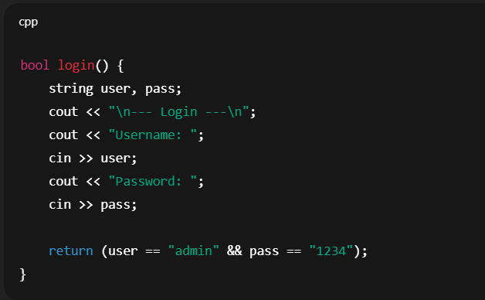

- Output

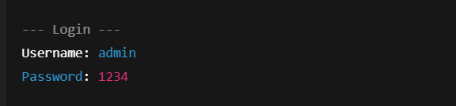

- Access granted; main menu appears.

- Add Student
Function: addStudent()
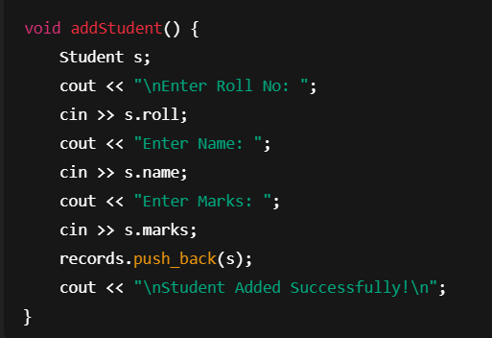
- Output:
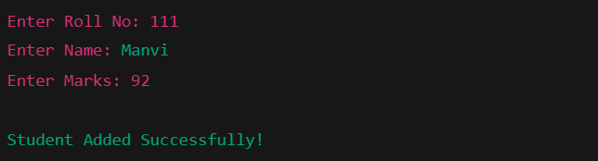
- Adds a new student to the records vector in memory.
- Reads roll number, name (single word), and marks.

- View Students
Function:viewstudent()
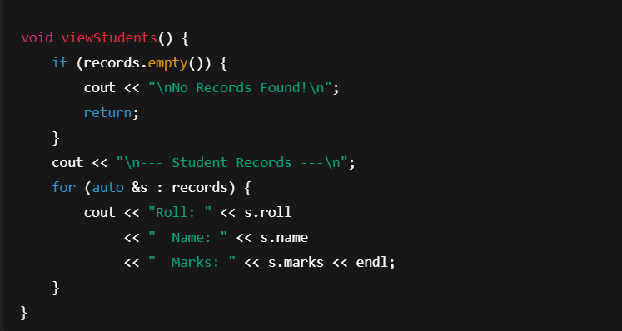

Output:

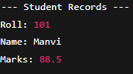

- Search Student
Function:searchstudent()
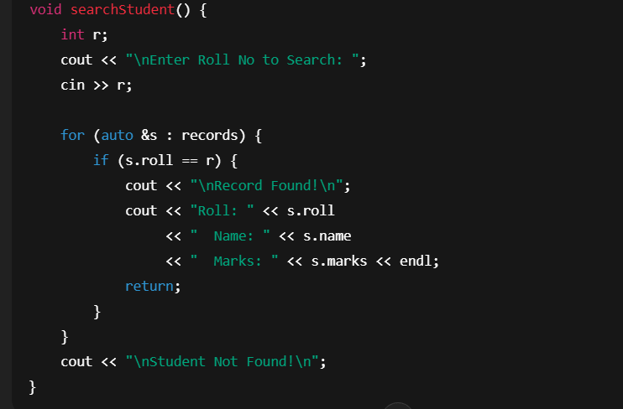

- Output:

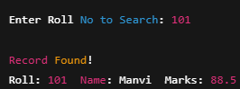

- Searches for a student by roll number.
- Prints the record if found; otherwise shows “Student Not Found”.

- Update Student
Function:updatestudent()
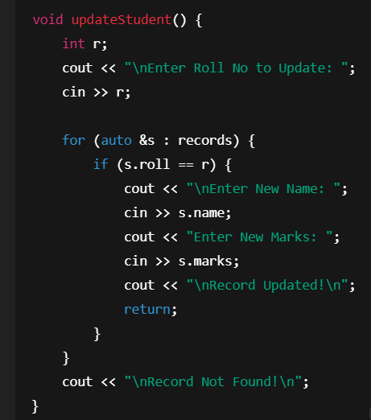

- Output:
• Updates a student’s name and marks by roll number.
• If roll number is not found, prints “Record Not Found”.

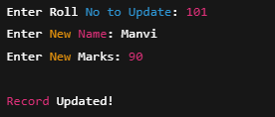

- Delete Student Module
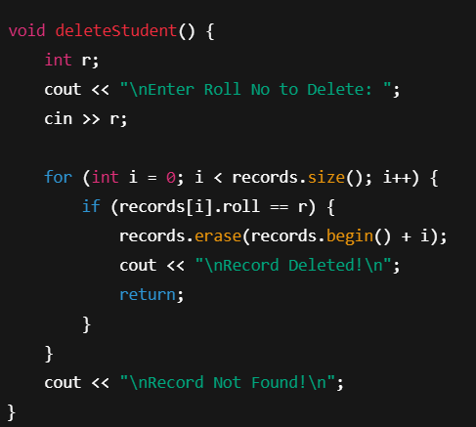

- Output:

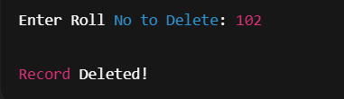

- Deletes a student by roll number.
- Prints confirmation if deleted or “Record Not Found” if roll number does not exist.

- Main Menu & Program Flow
- Output:

- Output:

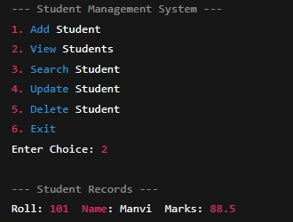
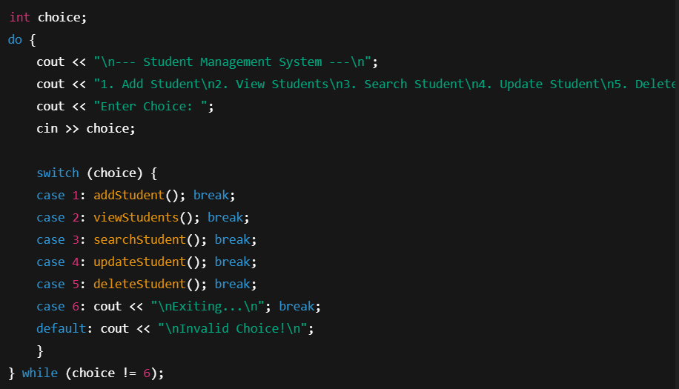

- Provides a menu-driven interface.
- Calls the appropriate function based on user choice.
- Loops until the user chooses Exit

DATA FLOW DIAGRAM

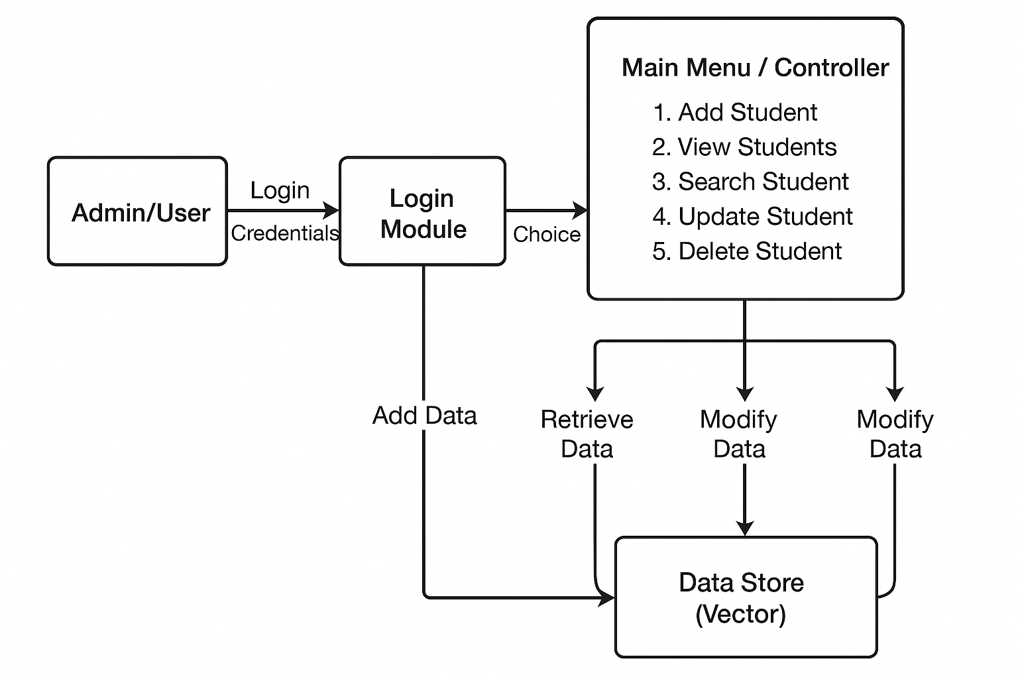

CONCLUSION
The Student Management System is a console-based application designed to efficiently manage student records through a menu-driven interface. It allows the admin to securely add, view, search, update, and delete student information, including roll number, name, and marks, using C++ structures and vectors. The system demonstrates basic CRUD operations and reinforces concepts of structured programming, data storage, and conditional logic. Although the current version stores data only in memory, it can be extended with file handling for persistent storage. Overall, the project provides a practical understanding of how to organize and manage student information digitally, highlighting both the importance of security and the ease of automated data handling in software applications.

FUTURE ENHANCEMENTS

Future enhancements for the Student Record Management System (SRMS) include adding persistent storage to save data across sessions, advanced search, filter, and sorting options, and the ability to update or delete records. Improvements in user experience with a clear menu, input validation, and informative messages, along with security features like password protection and user roles, would make the system safer and easier to use. Additional features like report generation, data export, backups, a graphical interface, and modular, object-oriented design with database integration would make the system more robust, maintainable, and scalable.

REFERENCES
- GeeksforGeeks. C++ File I/O and Student Record Management. https://www.geeksforgeeks.org/cpp-program-to-store-student-information-in-file/

- Programiz. C++ Classes and Objects Tutorial. https://www.programiz.com/cpp-programming/object-oriented-programming.

- Agarwal, P., & Sharma, R. (2019). Student Record Management System: A Review of Techniques and Applications. International Journal of Computer Applications, 178(10), 10–1c5.

- Sharma, A., & Gupta, N. (2018). Design and Implementation of Student Management System Using C++. International Journal of Advanced Research in Computer Science, 9(3), 25–30.

